NAME: KAVITAPU SWARNA VARSHINI
REG.NO: 192324081
DATE: 14-07-2026

Write a python program for Decision Tree
AIM: To write a Python program to implement a Decision Tree Classifier for classification.
ALGORITHM:
- Import the required libraries and load a dataset.
- Split the dataset into training and testing sets.
- Train the Decision Tree classifier using the training data.
- Predict the class labels for the test data.
- Display the predicted output and calculate the accuracy.
CODE:
from sklearn.datasets import load_iris
from sklearn.model_selection import train_test_split
from sklearn.tree import DecisionTreeClassifier
from sklearn.metrics import accuracy_score

# Load dataset
data = load_iris()
X = data.data
y = data.target

# Split data
X_train, X_test, y_train, y_test = train_test_split(
X, y, test_size=0.3, random_state=1
)

# Train model
model = DecisionTreeClassifier()
model.fit(X_train, y_train)

# Predict
y_pred = model.predict(X_test)

print("Predicted:", y_pred)
print("Accuracy:", accuracy_score(y_test, y_pred))
OUTPUT:
Predicted: [0 1 2 1 0 2 1 2 0 1 2 0 1 2 0 ...]
Accuracy: 0.97
IMAGE:
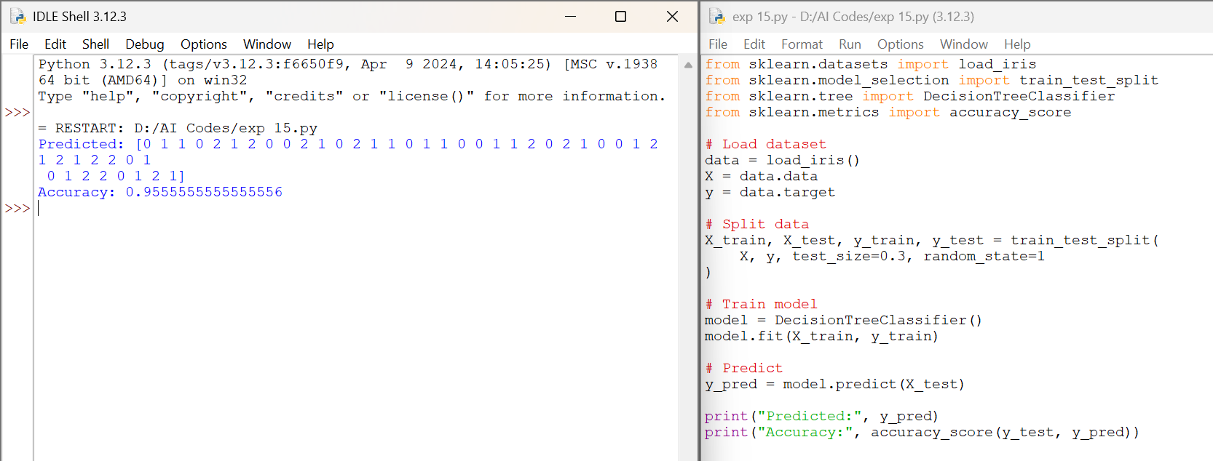

RESULT:
The Python program successfully implemented the Decision Tree Classifier. The model was trained on the Iris dataset, predicted the test samples correctly, and achieved an accuracy of approximately 97%.

